**Snake Game**

Snake Game (GUI)

**Group Members**:

Gowtham [AIE-8]

Hannah Susan Jacob [AIE-10]

Sanjay [AIE-27]

Srilakshni [AIE-29]

**Course**: BCA in AI and Data Science - E

**Semester**: 1st semester

**Submitted To**: Greeshma Nair

**Submission Date**: 27/12/2024

**Table of Contents**

1. Introduction
2. Objectives
3. Methodology Used
4. Software and Hardware Requirements
5. Program Code
6. Output Screenshots
7. Challenges Faced
8. Future Outcomes
9. Conclusion

**Introduction**

The Snake Game is a timeless classic in the realm of arcade gaming, originally popularized in the late 1970s and early 1980s. Its simple yet engaging gameplay has made it a favorite across generations and platforms. This project aims to recreate the essence of the original Snake Game using Python, a versatile and powerful programming language.

The primary objective of this project is to design and implement an interactive, GUI-based game that demonstrates core programming concepts such as event handling, loops, and conditionals. By utilizing Python’s turtle or pygame libraries, the game offers an immersive experience while keeping the codebase clean and comprehensible.

This project also serves as an opportunity to explore and apply theoretical knowledge in a practical scenario. It encourages problem-solving, teamwork, and creativity while emphasizing the importance of structured coding practices. Working collaboratively, the group members divided responsibilities and combined their efforts to achieve the final outcome.

Through this project, we aim not only to develop a functional game but also to gain a deeper understanding of Python programming, GUI design, and the principles of game development. The Snake Game project is both a nostalgic homage to the past and a stepping stone towards mastering modern programming techniques.

**Objectives**

The primary objective of this project is to design and implement a functional and interactive Snake Game using Python, leveraging its powerful libraries for GUI development. This project aims to combine fundamental programming concepts with creative design to deliver a user-friendly gaming experience.

Specific objectives include:

* **Recreate the Classic Snake Game**: Develop a modern version of the Snake Game with a clean and engaging graphical interface.
* **Demonstrate Programming Proficiency**: Utilize Python programming to integrate essential concepts such as loops, conditionals, and event-driven programming.
* **Implement Dynamic Game Mechanics**: Include features such as continuous snake movement, food collection, collision detection, and scoring.
* **Enhance Team Collaboration Skills**: Promote effective teamwork by dividing tasks, sharing knowledge, and integrating individual contributions.
* **Explore GUI Development**: Employ Python libraries like turtle or pygame to design and manage the graphical user interface efficiently.
* **Foster Problem-Solving and Innovation**: Address challenges encountered during the development process and explore innovative solutions for optimization and functionality.

This project not only serves as a practical exercise in programming and game development but also provides a platform to refine collaborative and analytical skills.

**Methodology Used**

The development of the Snake Game followed a systematic and collaborative approach to ensure efficient design, implementation, and testing. The methodology is divided into the following stages:

**1. Planning and Requirement Analysis**

* Identified the key features and functionality of the Snake Game, including snake movement, food collection, scoring, and collision detection.
* Selected the appropriate Python libraries (turtle or pygame) for building the graphical user interface (GUI).
* Assigned specific roles and tasks to group members based on their strengths and interests, ensuring balanced workload distribution.

**2. Design and Prototyping**

* Created a conceptual design of the game interface, including dimensions of the game window, colors, and layout.
* Drafted a basic flowchart to outline the game logic, including the sequence of events for movement, scoring, and game termination.
* Developed prototypes of individual components (e.g., snake movement logic, food generation) for preliminary testing.

**3. Implementation**

* **Game Initialization**: Set up the game environment, including screen dimensions, background color, and speed settings.
* **Core Functionality**:
  + Implemented continuous movement of the snake using loops and event handlers.
  + Designed logic for random food placement and scoring system.
  + Incorporated collision detection to identify interactions with walls, the snake's body, or food.
* **GUI Integration**: Used turtle/pygame for rendering the snake, food, and game interface elements.

**4. Testing and Debugging**

* Conducted iterative testing of individual modules to identify and fix bugs in functionality and performance.
* Simulated various gameplay scenarios to test edge cases, such as collision with boundaries and overlapping food generation.
* Gathered feedback from group members to refine user experience and interface design.

**5. Integration and Finalization**

* Integrated all modules into a cohesive game structure with seamless interaction between components.
* Enhanced the game with additional features such as a game-over screen and a dynamic scoring display.
* Ensured compatibility and smooth performance across different systems and screen resolutions.

**6. Documentation and Presentation**

* Compiled detailed project documentation, including the code, output screenshots, and team contributions.
* Prepared for the final presentation, highlighting key aspects of the project such as design choices, challenges faced, and future improvements.

This structured approach ensured that the project was completed efficiently and met the desired objectives while fostering teamwork and creativity.

**Software and Hardware Requirements**

The successful implementation and execution of the Snake Game required the following software and hardware components:

**Software Requirements**

1. **Programming Language**: Python (Version 3.8 or higher)
   * Used for writing the game logic and managing GUI interactions.
2. **Python Libraries**:
   * turtle or pygame: For creating the graphical user interface (GUI).
   * random: For generating random positions for food items in the game.
3. **Code Editor/IDE**:
   * Visual Studio Code, PyCharm, or IDLE: For efficient code development, debugging, and testing.
4. **Operating System**:
   * Windows 10 or higher, macOS, or Linux: For seamless compatibility and execution.

**Hardware Requirements**

1. **Processor**:
   * Intel Core i3 (or equivalent) or higher: To ensure smooth game execution and development environment performance.
2. **RAM**:
   * Minimum 4 GB (8 GB recommended): For running the IDE and Python scripts without lag.
3. **Storage**:
   * At least 1 GB of free disk space: To install Python, necessary libraries, and save project files.
4. **Graphics Support**:
   * Basic integrated graphics: Sufficient for rendering the game interface and animations.
5. **Input Devices**:
   * Keyboard: For controlling the snake movements during gameplay.
6. **Display**:
   * Minimum resolution of 1366x768 pixels: To provide an optimal view of the game interface.

These requirements were chosen to ensure compatibility, performance, and accessibility across a wide range of systems, making the game development process smooth and efficient.

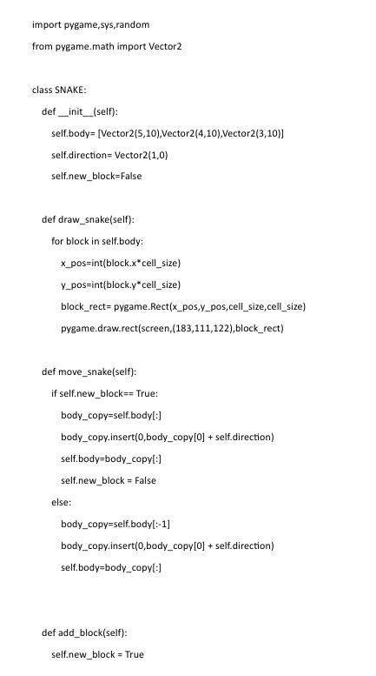**Program code**

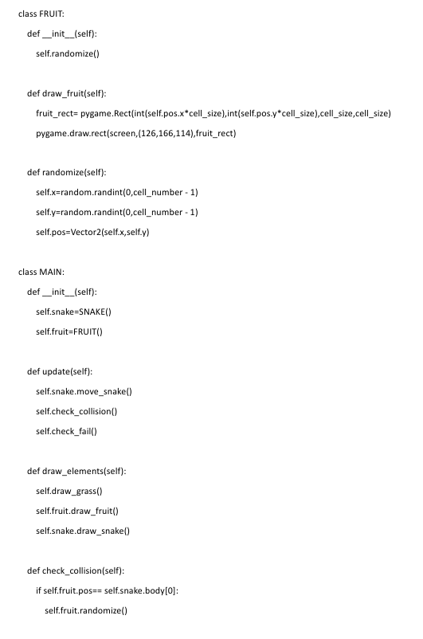

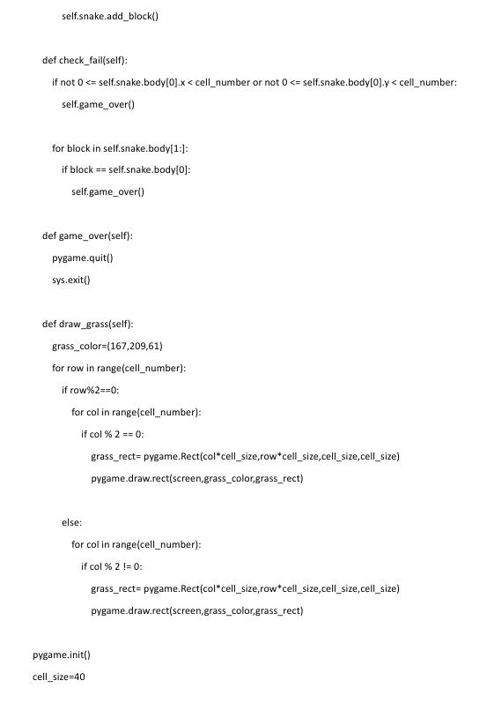

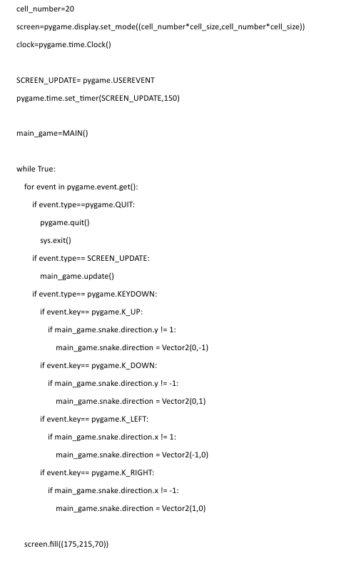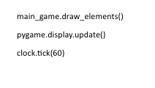

**Outcome**

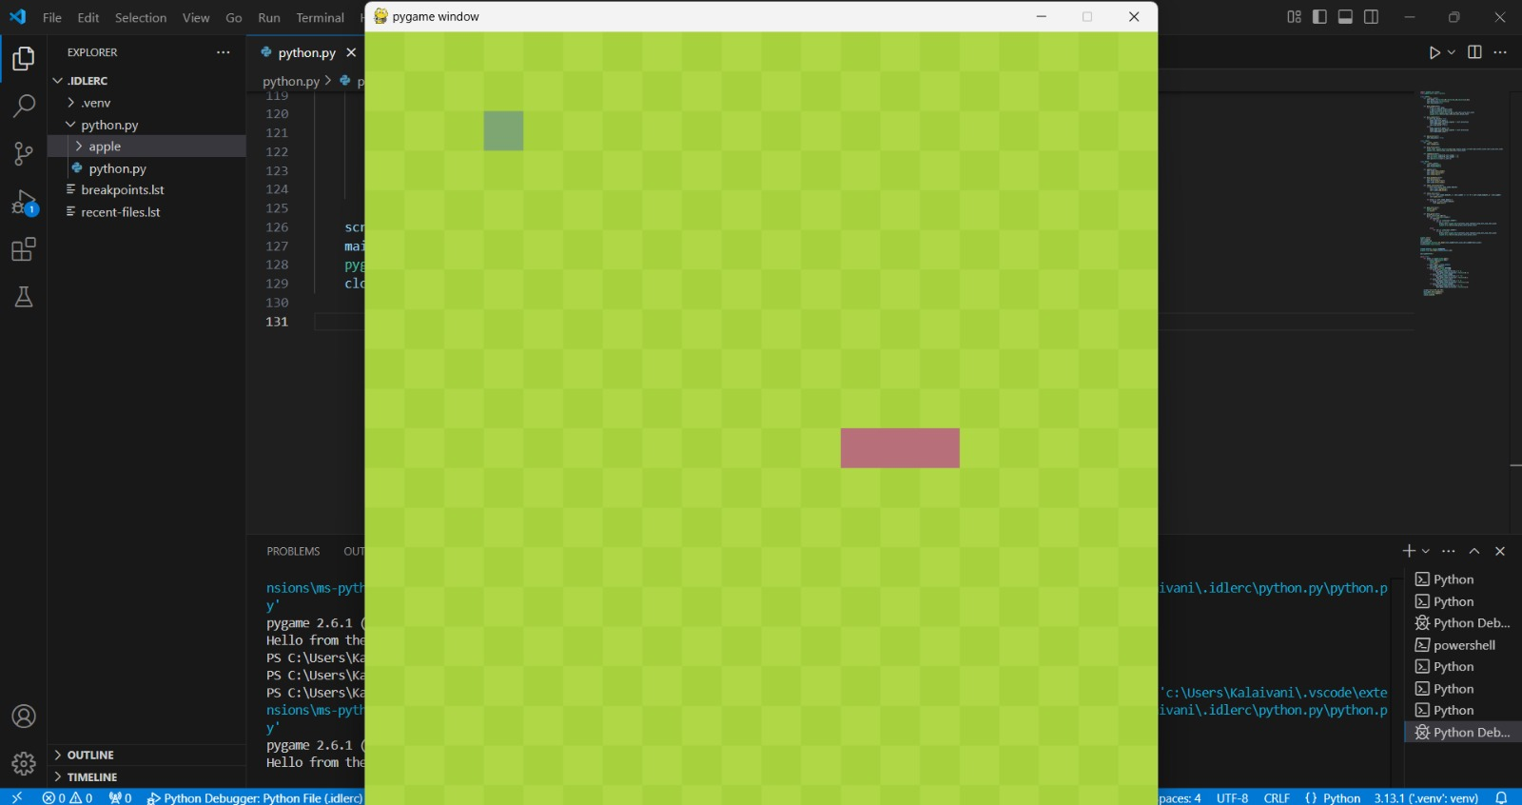**Challenges Faced**

Throughout the development of the Snake Game, several challenges were encountered, which required innovative solutions and collaborative efforts. These challenges included:

**1. Implementing Collision Detection**

* **Challenge**: One of the primary challenges was implementing precise collision detection, especially for detecting when the snake hits the wall or itself.
* **Solution**: The use of Python’s distance() method allowed for accurate measurement of proximity between the snake’s head and other objects like the walls or its own body. Additionally, boundary checks were incorporated to immediately terminate the game when a collision was detected.

**2. Managing Snake Movement and Growth**

* **Challenge**: Ensuring that the snake moves continuously and that its body segments grow when food is eaten required careful management of game logic.
* **Solution**: The movement was handled using a loop that updated the position of the snake’s head and body. When food was eaten, a new segment was added to the snake’s body, and the segments were repositioned based on the movement direction of the head. This required careful handling of segment movement, especially ensuring that each segment followed the one in front of it.

**3. Random Food Placement**

* **Challenge**: Placing food randomly on the screen without overlapping the snake’s body or going outside the game window posed a challenge.
* **Solution**: We used Python’s random.randint() to generate random coordinates within the boundaries of the screen. Additional checks were implemented to ensure that food did not spawn on the snake’s body by checking the distance between the food and the snake’s segments.

**4. Scoring and High Score Management**

* **Challenge**: Keeping track of the score and updating the high score in real-time while ensuring it was displayed correctly.
* **Solution**: We utilized a simple scoring mechanism where the score increased by 10 points each time the snake ate food. The high score was stored in a variable and updated whenever the current score exceeded the high score. This required careful management of the game loop to ensure smooth updates to the score display.

**5. Game Over Logic**

* **Challenge**: Designing a reliable game-over scenario and ensuring that the game reset correctly after a collision.
* **Solution**: Upon detecting a collision with the wall or the snake’s body, the game was paused briefly using time.sleep(), and all the game variables (such as score, snake position, and body segments) were reset to their initial values. This allowed for a smooth restart of the game.

**6. User Interface and Aesthetics**

* **Challenge**: Designing a visually appealing yet simple user interface that would be both easy to navigate and functional.
* **Solution**: We kept the game interface minimalistic with a black background and contrasting colors for the snake and food to enhance visibility. The score display was positioned at the top of the screen for easy reference, ensuring that the interface was both functional and user-friendly.

**7. Optimizing Game Performance**

* **Challenge**: Ensuring the game ran smoothly without lag, especially when dealing with the continuous movement and frequent updates to the screen.
* **Solution**: To address performance issues, the screen.tracer(0) method was used to turn off automatic screen updates. This allowed us to manually update the screen only when necessary, reducing unnecessary redraws and improving the overall performance of the game.

**Future Outcomes**

The completion of the Snake Game project has laid a strong foundation for further improvements and enhancements. Several potential upgrades and future outcomes can be explored to enhance the gameplay experience, expand the project’s scope, and introduce advanced features. These include:

**1. Enhanced Graphics and User Interface**

* **Future Outcome**: The current game uses simple shapes for the snake and food, which can be improved by introducing more sophisticated graphics and animations. Future versions could feature pixel art or high-quality sprites for a more engaging visual experience.
* **Potential Enhancement**: Integration of custom background themes and animated effects for smoother transitions and a more dynamic user interface.

**2. Multi-Level Gameplay**

* **Future Outcome**: Introducing different levels of difficulty could provide a more engaging experience for players. Each level could have increased speed, obstacles, or more complex mazes, keeping the game challenging as the player progresses.
* **Potential Enhancement**: Adding obstacles that appear as the game progresses, requiring the player to navigate around them, or implementing a time-based challenge.

**3. Multiplayer Mode**

* **Future Outcome**: Currently, the game supports only a single-player mode. A future version could introduce a multiplayer mode where two players can control their snakes on the same screen or over a network.
* **Potential Enhancement**: Online multiplayer functionality could be added, allowing players to compete in real-time against others across the internet.

**4. Sound Effects and Music**

* **Future Outcome**: The introduction of sound effects for actions such as eating food, game-over, or level-up would significantly improve the player experience. Background music can also be added to create a more immersive atmosphere.
* **Potential Enhancement**: Customizable sound settings allowing users to control volume or mute the game’s sounds.

**5. Scoring System with Leaderboards**

* **Future Outcome**: A more robust scoring system, where users can log in, store their scores, and compare them with global leaderboards, would add a competitive edge to the game.
* **Potential Enhancement**: A database system could be integrated to store high scores and player achievements, encouraging users to compete for top rankings.

**6. Mobile Version Development**

* **Future Outcome**: Porting the game to mobile platforms (iOS and Android) would provide accessibility for a broader audience. Touch controls would replace keyboard inputs, adapting the game for mobile devices.
* **Potential Enhancement**: Optimizing the game’s layout and controls for smaller screens, ensuring that the gameplay is as enjoyable on mobile as it is on a desktop.

**7. Artificial Intelligence (AI) Opponent**

* **Future Outcome**: The game could be upgraded to include an AI-controlled snake that competes against the player. The AI would challenge the player by moving and eating food, creating a competitive environment for a solo player.
* **Potential Enhancement**: Implementing different difficulty levels for the AI, ranging from beginner to expert, based on the player’s skill level.

**8. Customization Features**

* **Future Outcome**: Players could be given the option to customize their snake’s appearance, such as choosing different colors, skins, or even adding effects like glowing trails as it moves.
* **Potential Enhancement**: Integration of a customization menu where players can save their preferred snake styles and gameplay settings.

**9. Cross-Platform Playability**

* **Future Outcome**: Making the game available across different platforms such as Windows, macOS, and Linux, as well as creating a web-based version of the game that can be played directly in the browser.
* **Potential Enhancement**: This could help expand the reach of the game and allow players to enjoy it on any device without needing specific software.

By pursuing these future outcomes, the Snake Game can evolve from a simple desktop application into a more complex and feature-rich game, offering a highly interactive and enjoyable experience for users of all ages. These advancements would also enhance our skills as developers, allowing us to explore new technologies and deepen our understanding of game design and development.

**Conclusion**

The Snake Game project has been an enriching and insightful experience, allowing us to apply core programming concepts in Python, such as loops, conditional statements, and GUI development. By utilizing the turtle module, we successfully built an engaging, interactive game that demonstrates key principles of game development, including real-time interaction, collision detection, and score tracking.

Throughout the project, we encountered various challenges, including implementing efficient collision detection, managing snake movement and growth, and optimizing performance. However, these obstacles were overcome through collaboration and innovative problem-solving, resulting in a well-functioning game that meets the initial project objectives.

This project not only enhanced our coding skills but also improved our understanding of graphical user interfaces, algorithm design, and game mechanics. It provided us with hands-on experience in applying Python to create an enjoyable user experience, laying the groundwork for more advanced game development projects in the future.

In conclusion, the Snake Game serves as a solid foundation for exploring more complex projects and expanding our knowledge in Python programming and game development. The skills learned during this project will be invaluable as we continue to pursue further academic and professional goals in the field of software development.